Abstract template for the August 2022 Erice workshop
[Title: Times New Roman, 16p, Bold, centered]

[1 blank line after the title. Remove all text in red]
First Author¹, William Shakespeare², and S. Forkbeard^{1,2}
[Name: Times New Roman, 12p, centered, underline presenting author]
¹Department of Hot Air, Bigheaded University, 1 Main Road, College Town, NY 12345, USA
²The Globe, 1 New Globe Walk, Bankside, London SE1 9DT London 234-4X7, UK
[Affiliation; Times New Roman,10.5p, centered]
[1 blank line after affiliation]
Please save your abstract in PDF format and email to deamn22@mail.com before August 1, 2022.
The workshop will have several slots for “hot topic” talks. The selection will be made from the abstracts submitted before the hot topic request deadline of July 1, 2022 [1,2]. [Font: Times New Roman, 10.5p]

Please do not change the page size, margins and spacing.
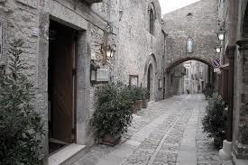

Fig.1 Downtown Erice. [9p]

References [10.5p]
[1] J. J. Thomson, “Cathode Rays,” Philos. Mag. 44, 293 (1897). [9p]
[2] H. W. Kroto, J. R. Heath, S. C. O'Brien, R. F. Curl, and R. E. Smalley, “C₆₀: Buckminsterfullerene,” Nature 318, 162 (1985).

